Polysemes

🔹 What Are Polysemes
# Source: AI Source: Provided by: [Data Path: Persons Table -> ID Column: 1, Name_En Column: Motasem Essam] -> From: [Chatgpt (GPT-4-turbo)] on [8/1/2025]
A polyseme is a single word that has multiple related meanings.
Unlike true homonyms (which have unrelated meanings), polysemes share a core idea or conceptual link between their senses.
From Greek: poly = many, sema = sign
So: “one word, many related meanings”

🧱 Key Features of Polysemes
# Source: AI Source: Provided by: [Data Path: Persons Table -> ID Column: 1, Name_En Column: Motasem Essam] -> From: [Chatgpt (GPT-4-turbo)] on [8/1/2025]
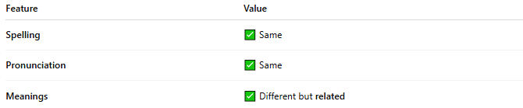
Feature | Value
Spelling | ✅ Same
Pronunciation | ✅ Same
Meanings | ✅ Different but related

📝 Examples of Polysemes
# Source: AI Source: Provided by: [Data Path: Persons Table -> ID Column: 1, Name_En Column: Motasem Essam] -> From: [Chatgpt (GPT-4-turbo)] on [8/1/2025]
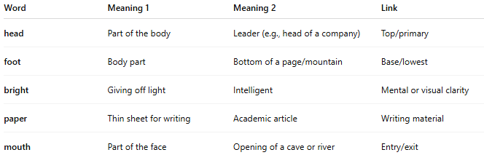
Word | Meaning 1 | Meaning 2 | Link
head | Part of the body | Leader (e.g., head of a company) | Top/primary
foot | Body part | Bottom of a page/mountain | Base/lowest
bright | Giving off light | Intelligent | Mental or visual clarity
paper | Thin sheet for writing | Academic article | Writing material
mouth | Part of the face | Opening of a cave or river | Entry/exit

🔁 Polysemy vs Homonymy
# Source: AI Source: Provided by: [Data Path: Persons Table -> ID Column: 1, Name_En Column: Motasem Essam] -> From: [Chatgpt (GPT-4-turbo)] on [8/1/2025]
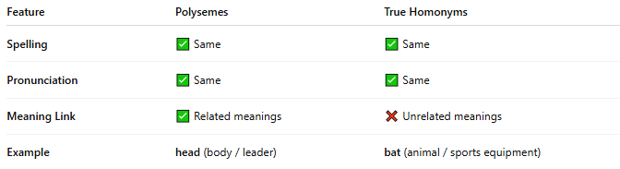
Feature | Polysemes | True Homonyms
Spelling | ✅ Same | ✅ Same
Pronunciation | ✅ Same | ✅ Same
Meaning Link | ✅ Related meanings | ❌ Unrelated meanings
Example | head (body / leader) | bat (animal / sports equipment)

🎨 Use in Language
# Source: AI Source: Provided by: [Data Path: Persons Table -> ID Column: 1, Name_En Column: Motasem Essam] -> From: [Chatgpt (GPT-4-turbo)] on [8/1/2025]
- Makes English flexible and efficient — one word can do multiple jobs.
- Used heavily in metaphors, idioms, and figurative language.
- Important for language learners and semantic analysis.

🧠 How to Identify a Polyseme
# Source: AI Source: Provided by: [Data Path: Persons Table -> ID Column: 1, Name_En Column: Motasem Essam] -> From: [Chatgpt (GPT-4-turbo)] on [8/1/2025]
Ask:
Are the meanings conceptually linked, like parts of a metaphor or a shared function?
If yes → polyseme
If no → likely a homonym

